**Final Project: Lab**

Madelyn Wolf

Information Technology, Arizona State University

IFT 320: Managing the Cloud

Professor John Lewis

December 3rd, 2025

**Final Project: Lab**

**Figure 1**

*A screenshot of the security group Wolf FP SG in the AWS Academy Learner Lab with my account ID and user ID in the top right corner.*

**Figure 2**

*A screenshot of the EC2 Instance WolfFP1 running with the correct instance type in the AWS Academy Learner Lab with my account ID and user ID in the top right corner.*

**Figure 3**

*A screenshot of the EC2 Instance WolfFP1 with the correct AMI in the AWS Academy Learner Lab with my account ID and user ID in the top right corner.*

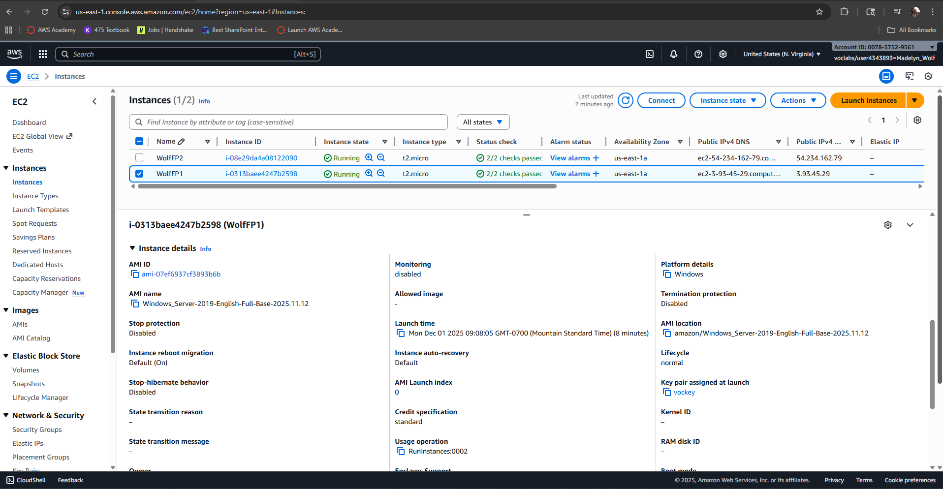

**Figure 4**

*A screenshot of the EC2 Instance WolfFP1 showing the security group attached in the AWS Academy Learner Lab with my account ID and user ID in the top right corner.*

**Figure 5**

*A screenshot of the EC2 Instance WolfFP1 showing the storage volume attached in the AWS Academy Learner Lab with my account ID and user ID in the top right corner.*

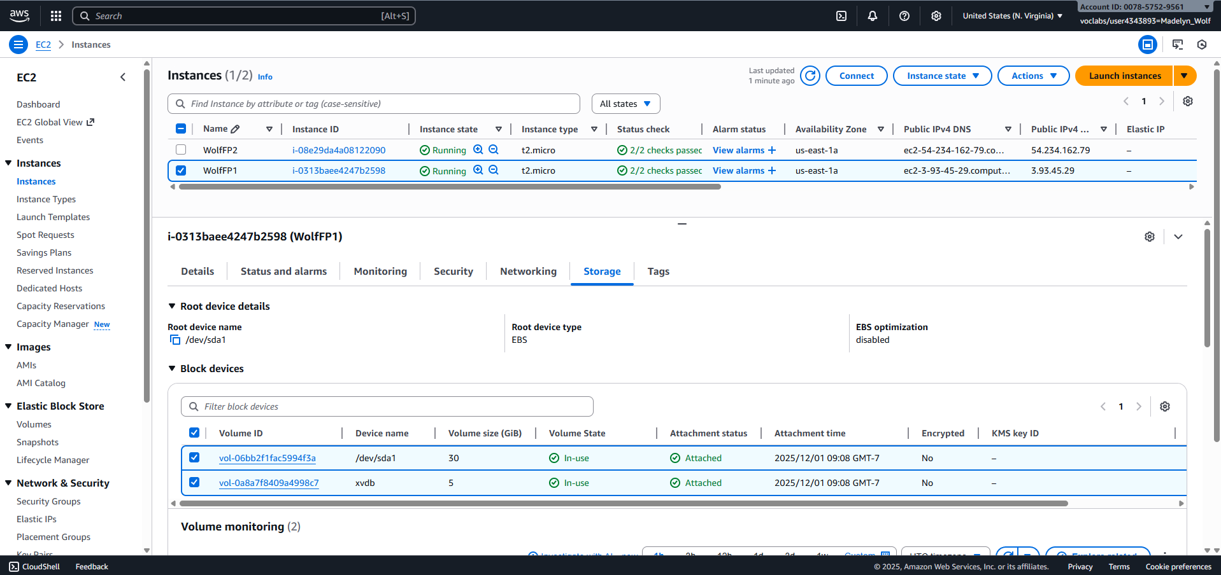

**Figure 6**

*A screenshot of the EC2 Instance WolfFP2 running with the correct instance type in the AWS Academy Learner Lab with my account ID and user ID in the top right corner.*

**Figure 7**

*A screenshot of the EC2 Instance WolfFP2 with the correct AMI in the AWS Academy Learner Lab with my account ID and user ID in the top right corner.*

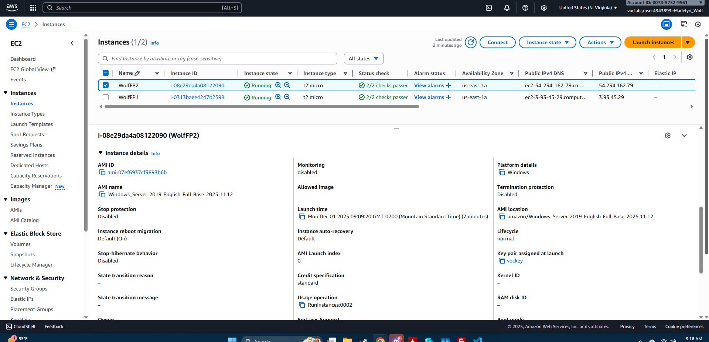

**Figure 8**

*A screenshot of the EC2 Instance WolfFP2 showing the security group attached in the AWS Academy Learner Lab with my account ID and user ID in the top right corner.*

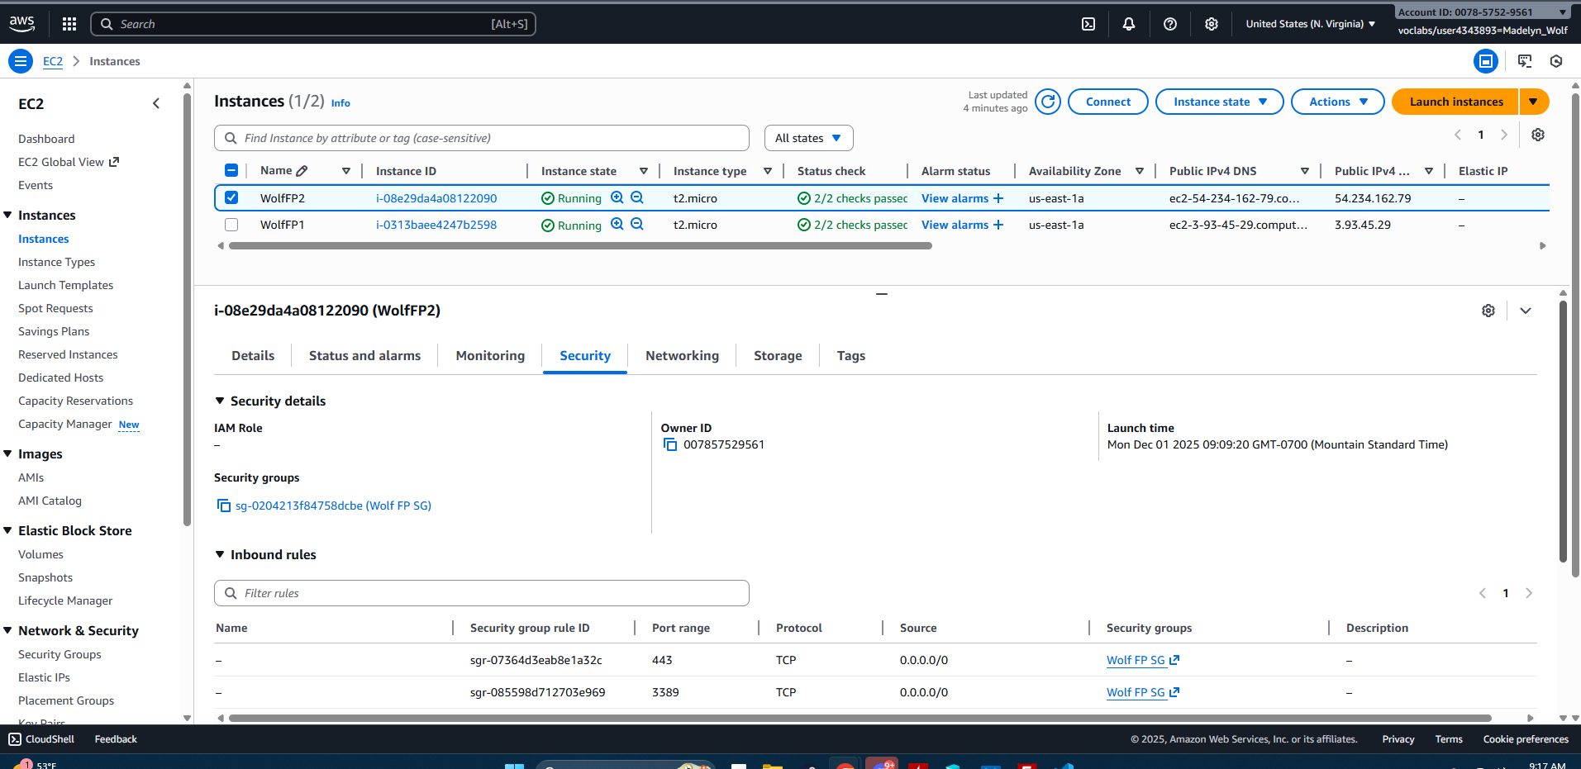

**Figure 9**

*A screenshot of the EC2 Instance WolfFP2 showing the storage volume attached in the AWS Academy Learner Lab with my account ID and user ID in the top right corner.*

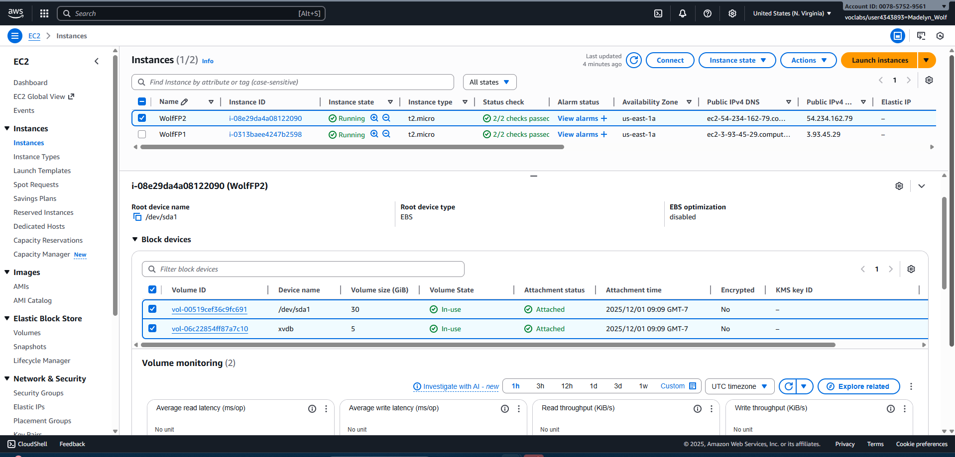

**Figure 10**

*A screenshot of the EC2 Instance WolfFP1 after connecting with RDP showing the renamed computer according to the outlined naming convention.*

**Figure 11**

*A screenshot of the EC2 Instance WolfFP1 after connecting with RDP showing the D: drive, formatted according to the outlined naming convention.*

**Figure 12**

*A screenshot of the EC2 Instance WolfFP1 after connecting with RDP showing IIS was installed.*

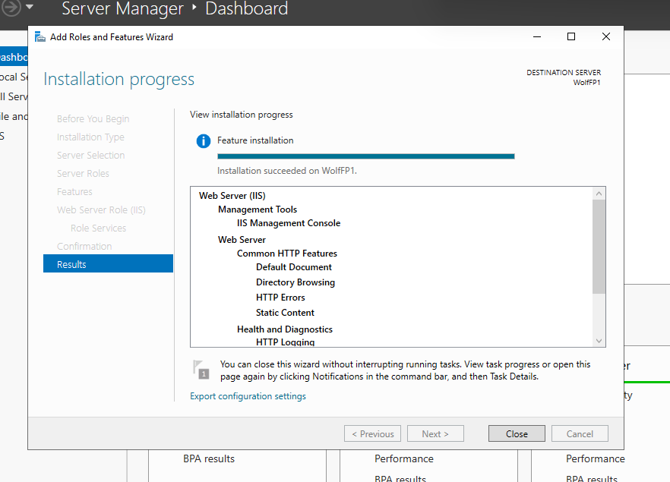

**Figure 13**

*A screenshot of the EC2 Instance WolfFP1 after connecting with RDP showing the browser with http://localhost and the custom webpage message.*

**Figure 14**

*A screenshot of the EC2 Instance WolfFP2 after connecting with RDP showing the renamed computer according to the outlined naming convention.*

**Figure 15**

*A screenshot of the EC2 Instance WolfFP2 after connecting with RDP showing the D: drive, formatted according to the outlined naming convention.*

**Figure 16**

*A screenshot of the EC2 Instance WolfFP2 after connecting with RDP showing IIS was installed.*

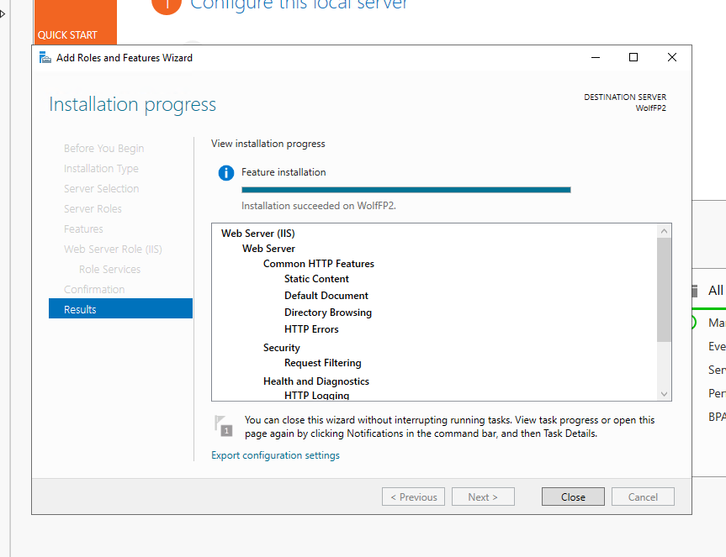

**Figure 17**

*A screenshot of the EC2 Instance WolfFP2 after connecting with RDP showing the browser with http://localhost and the custom webpage message.*

**Figure 18**

*A screenshot of the LoadBalancer WolfFPLB summary page, showing it is active and has the correct security group attached in the AWS Academy Learner Lab with my account ID and user ID in the top right corner.*

**Figure 19**

*A screenshot of the attached Target Group, WolfFPTG, showing that both nodes are healthy in the AWS Academy Learner Lab with my account ID and user ID in the top right corner.*

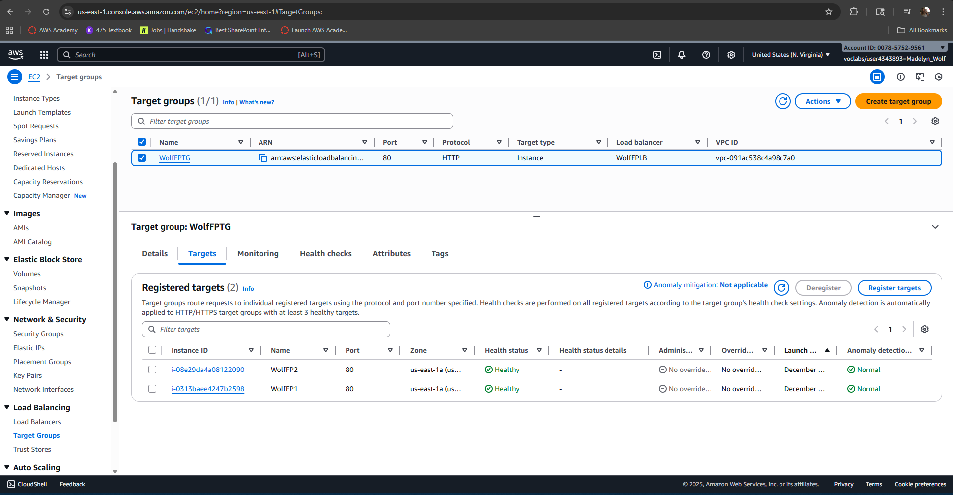

**Figure 20**

*A screenshot of the browser accessing the webpage using the LoadBalancer DNS name, WolfFPLB-789804959.us-east-1.elb.amazonaws.com.*

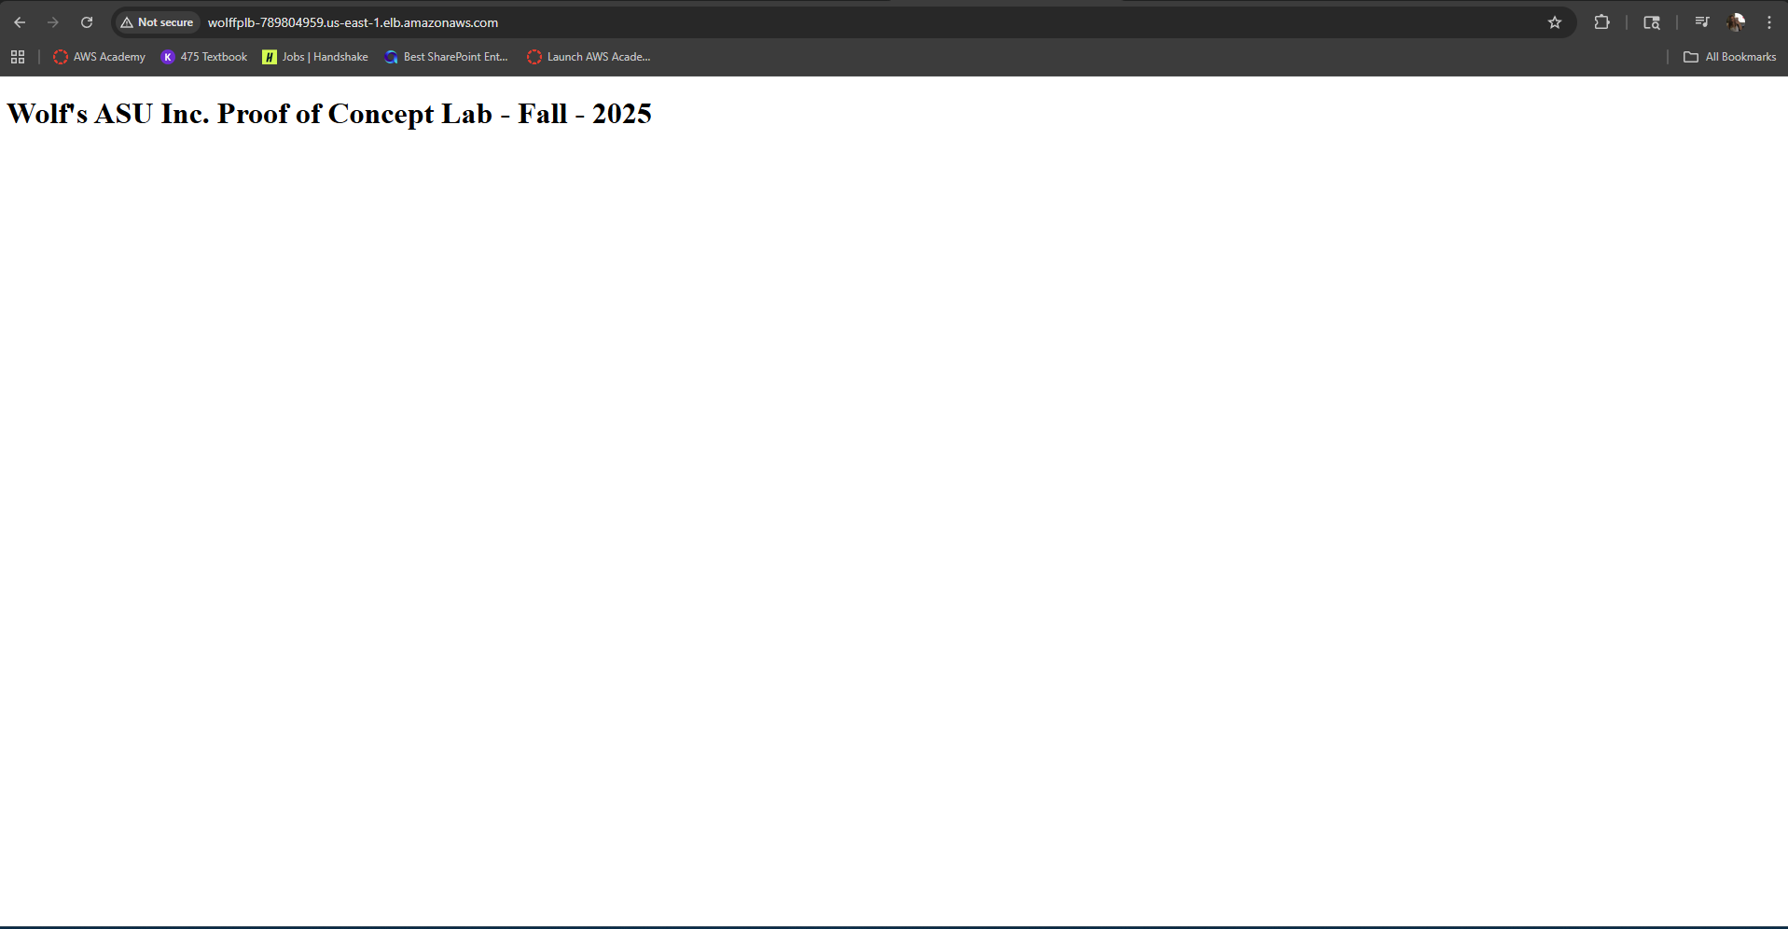

**Figure 21**

*A screenshot of the Hosted Zone IFT320Fall2025.com and the records in Route 53 in the AWS Academy Learner Lab with my account ID and user ID in the top right corner.*

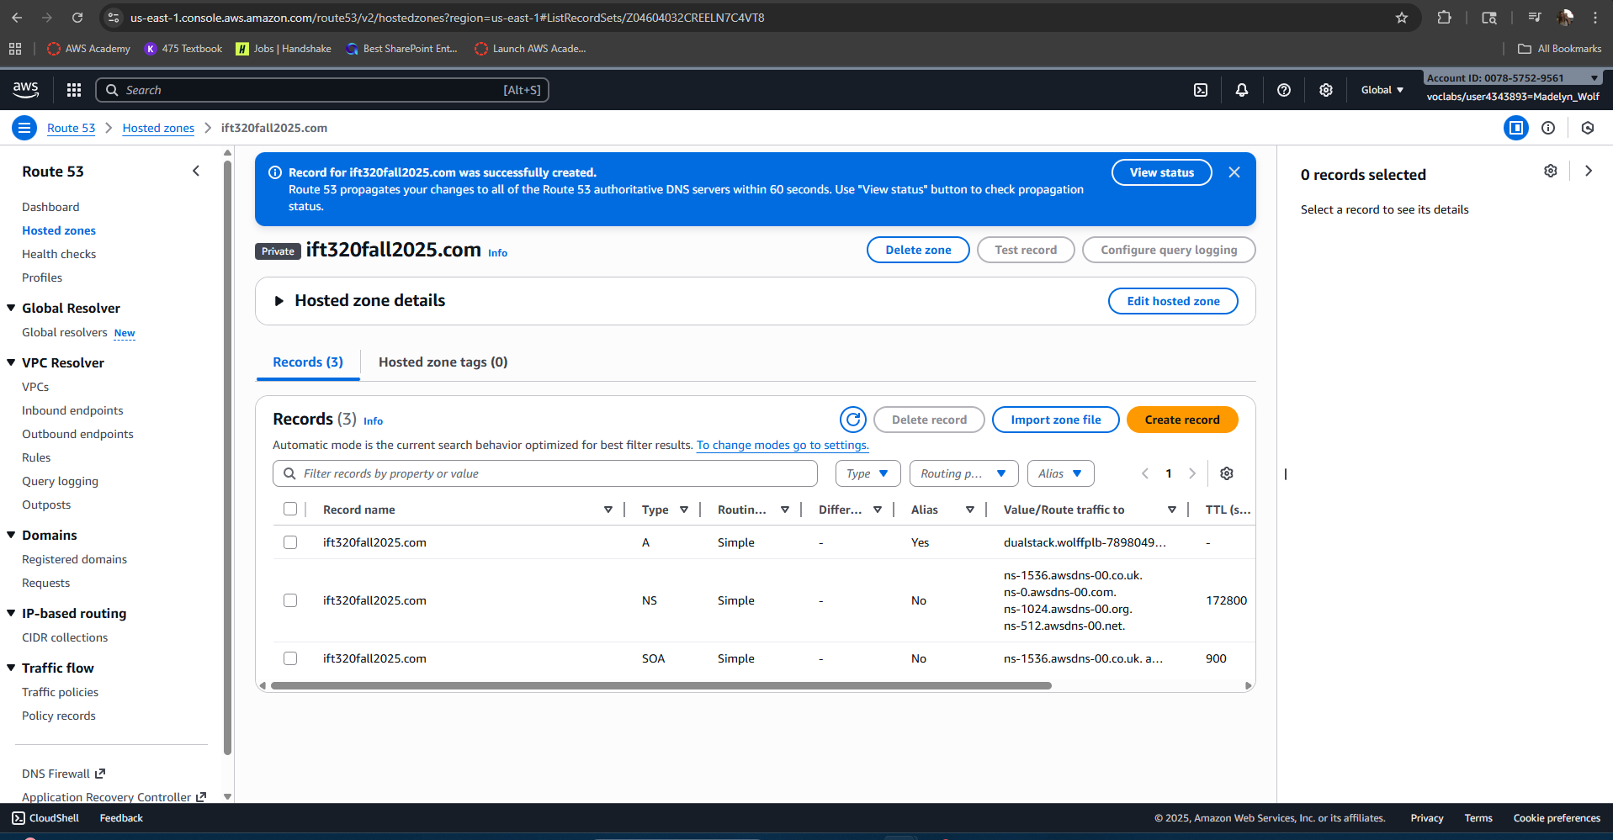

**Figure 22**

*A screenshot of the CloudWatch metric CPUUtilization for EC2 Instance WolfFP1 in the AWS Academy Learner Lab with my account ID and user ID in the top right corner.*

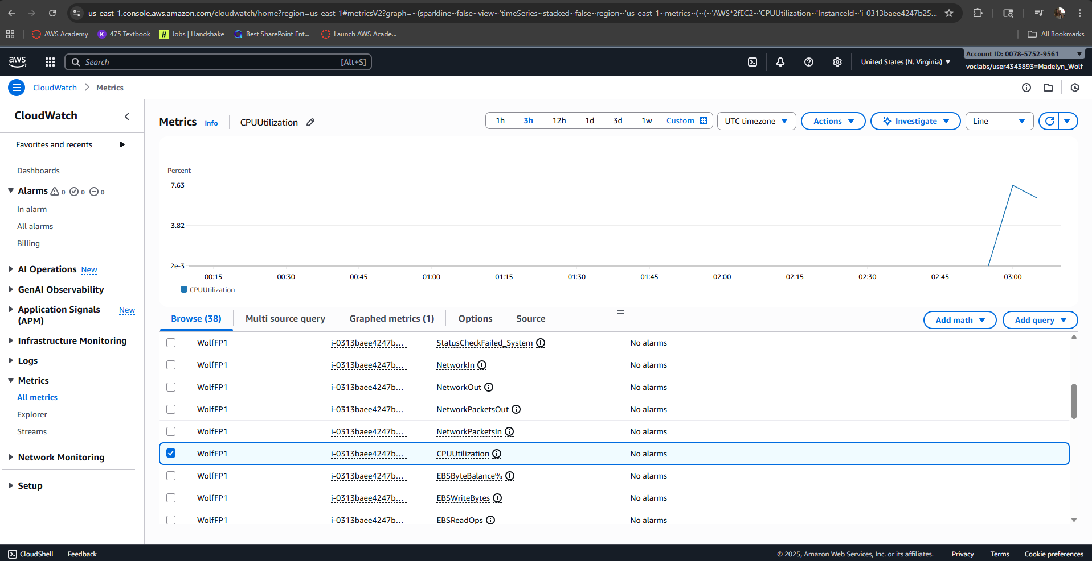

**Figure 23**

*A screenshot of the CloudWatch metrics Network In and Network Out for EC2 Instance WolfFP1 in the AWS Academy Learner Lab with my account ID and user ID in the top right corner.*

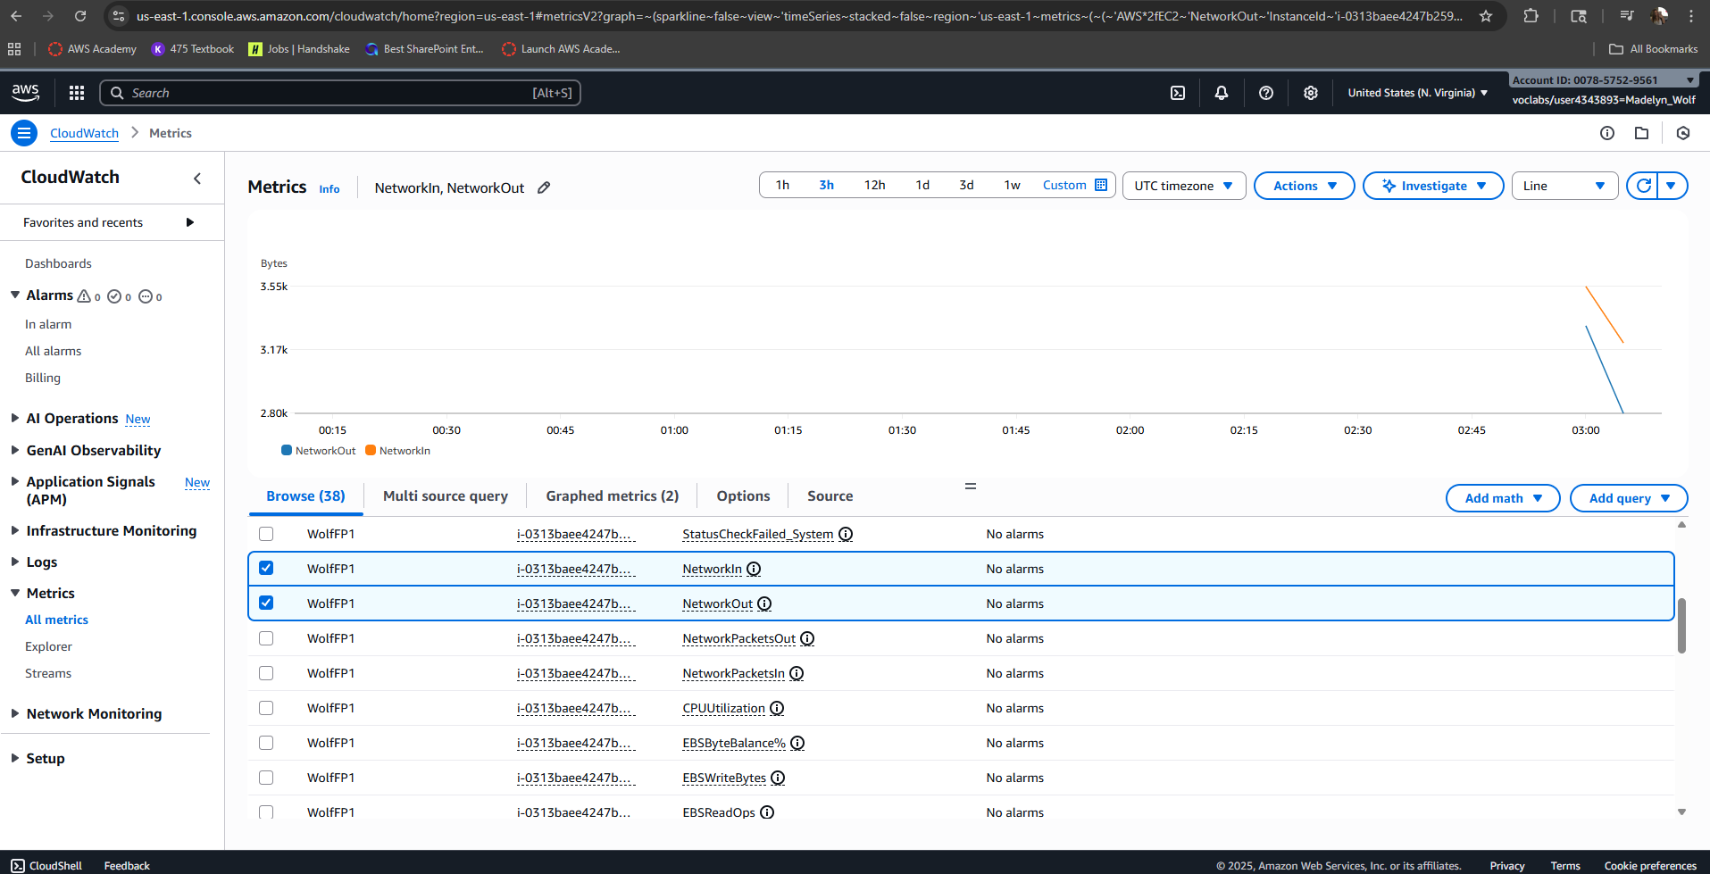

**Figure 24**

*A screenshot of the CloudWatch metric CPUUtilization for EC2 Instance WolfFP2 in the AWS Academy Learner Lab with my account ID and user ID in the top right corner.*

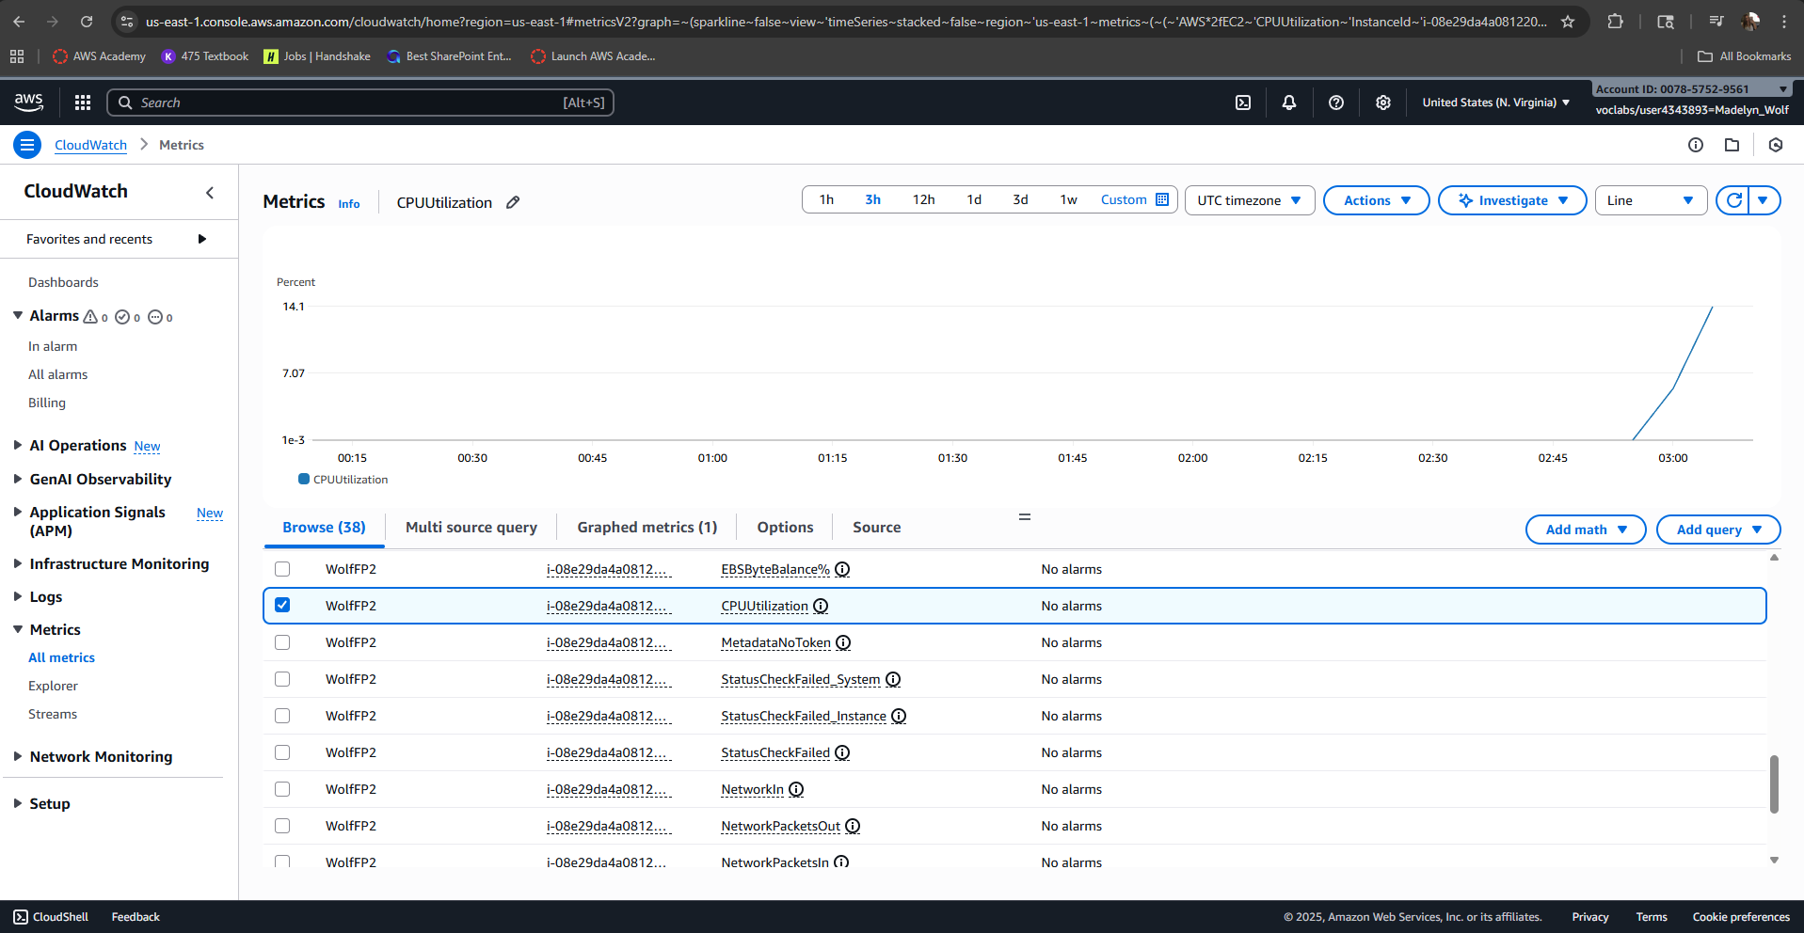

**Figure 25**

*A screenshot of the CloudWatch metrics Network In and Network Out for EC2 Instance WolfFP2 in the AWS Academy Learner Lab with my account ID and user ID in the top right corner.*

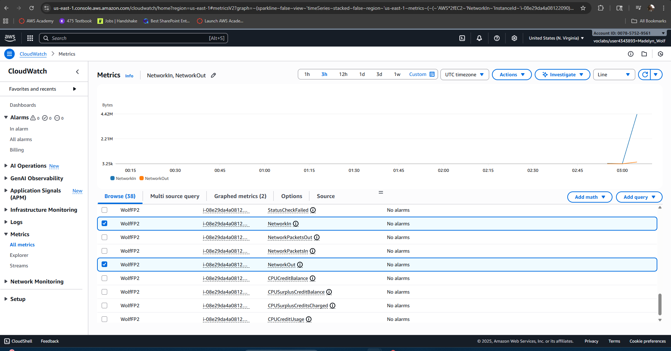

**Figure 26**

*A screenshot of the DynamoDB table WolfFPContacts showing all six entries in the AWS Academy Learner Lab with my account ID and user ID in the top right corner.*

